**Jenkins Task-04  
==================**

1)SetupjenkinsCICDpipelineusingfreestylejobusingDockercontainersusingbelowcode. https://github.com/betawins/hiring-app.git

Stages:

* 1. GitClone
  2. SonarqubeIntegration
  3. MavenCompilation
  4. NexusArtifactory
  5. SlackNotification
  6. DeployOntomcat.

# SetupjenkinsCICDpipelineusingfreestylejob

* + - TodothatthesetaskfirstIneedserver.
    - HeremyserverisAvailable.
    - Connecttheserverandinstalljava,Afterthatinstall Jenkins.

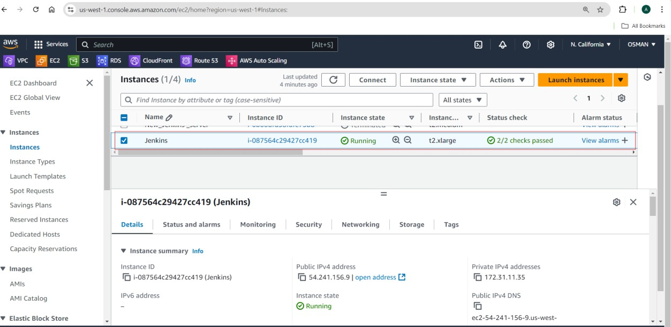

ToinstalljavaCMD:sudoyum-yinstalljava-17*

Click on the below URL here you find script to install Jenkins. <https://www.jenkins.io/doc/book/installing/linux/#red-hat-centos>

AfterperformtheallScriptyouneedtobelow commands.

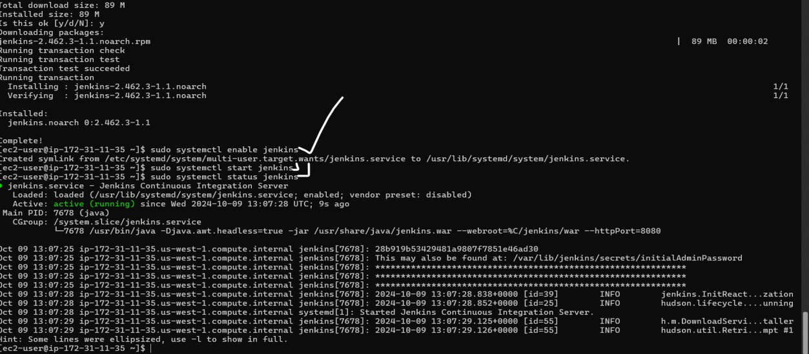

Nowgotothebrowser.

Inbrowserpaste<ipaddress:8080> youwillbeseethebelowinterface.

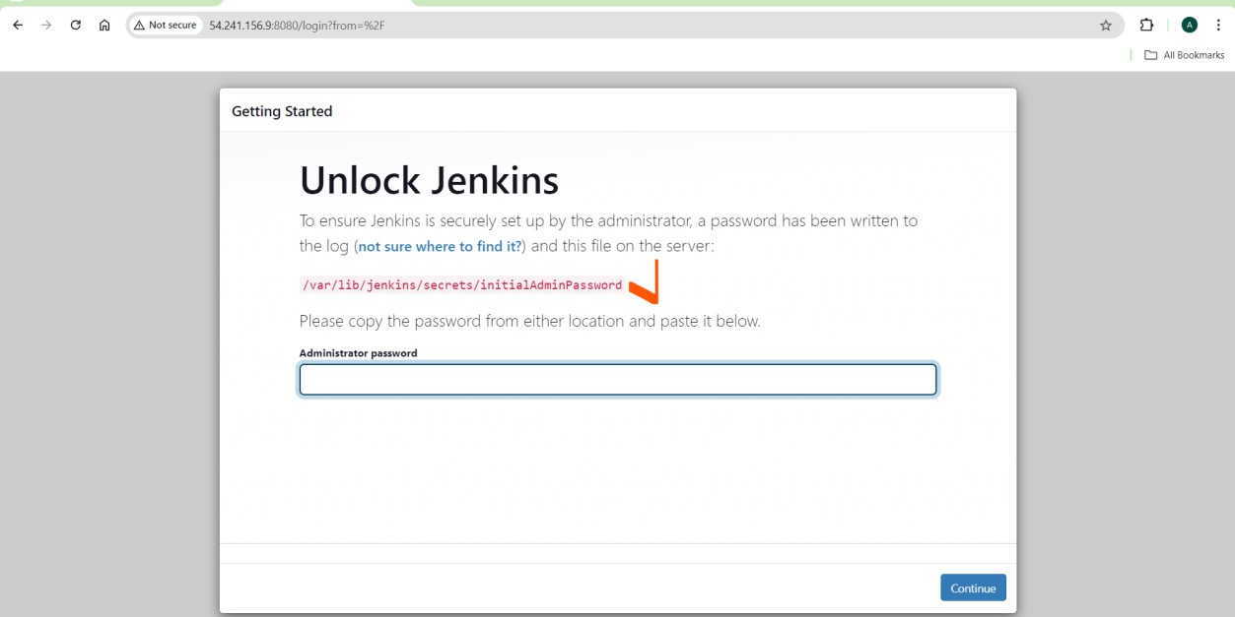

Gotoserverthereyouwillfindthepasswordof Jenkins.



Afterenterthepasswordclickontheinstallplugins.

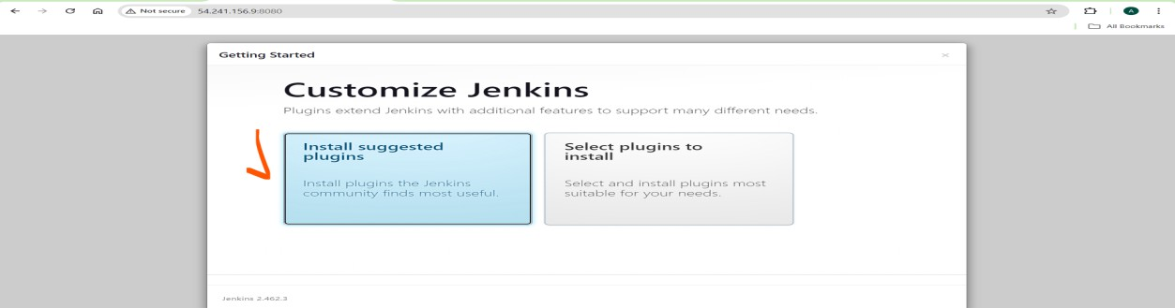

Heregiveusernameandpassword. Just click on save and continue.

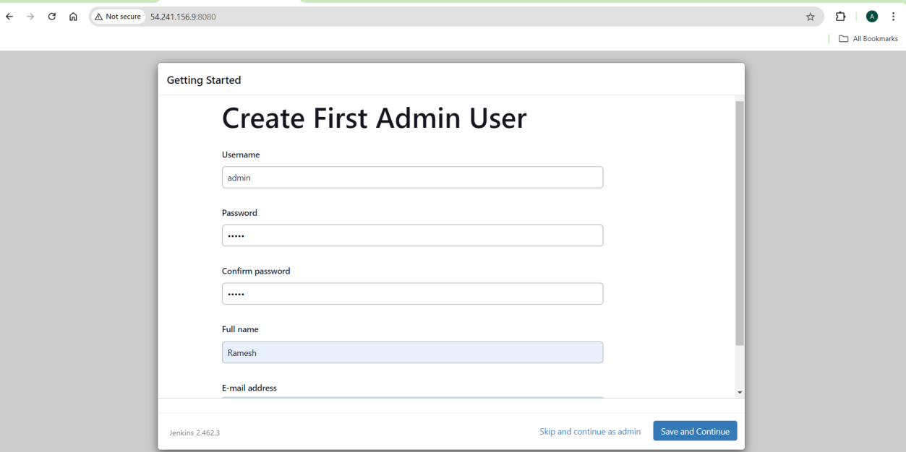

NowyouwillseeJenkins Dashboard.

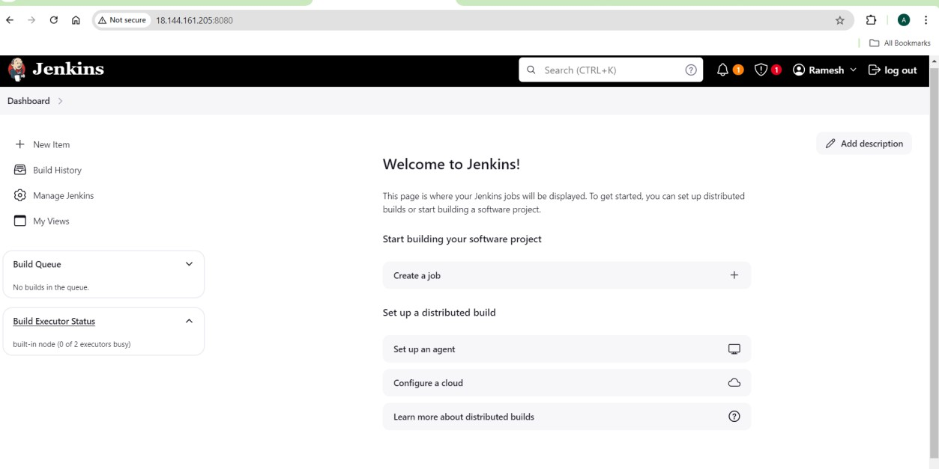

JenkinsinstallationandLoginus successful.

# SonarqubeIntegration

* Nowyouneedtoinstall Sonarqube.
* UsingtheDockerinstallSonarqube.
* Firstneedtoinstalldocker,enable,start,andcheckthestatus.
* CMD:sudoyum-yinstalldocker---toinstalldocker

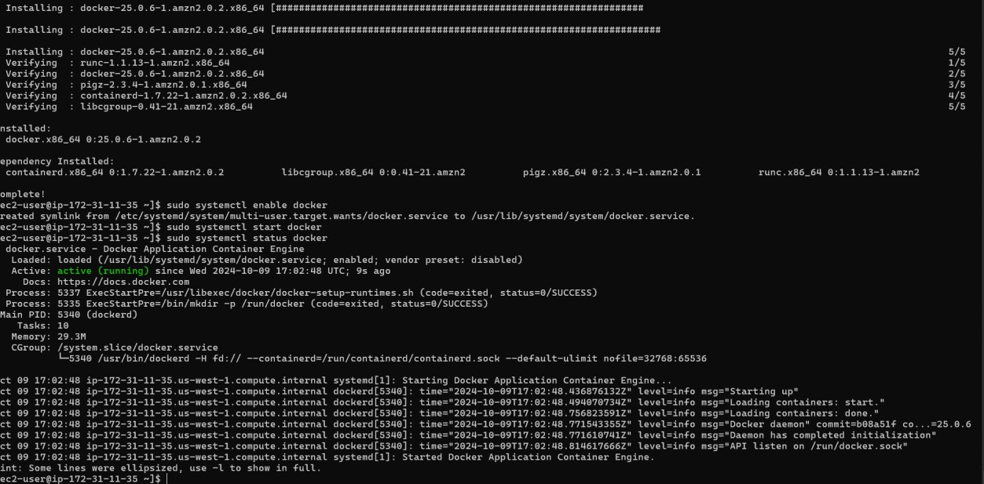

Nowyouneedtoinstallsonarqubeusingthedocker.

CMD:sudodockerrun-d--namesonarqube-p9000:9000sonarqube

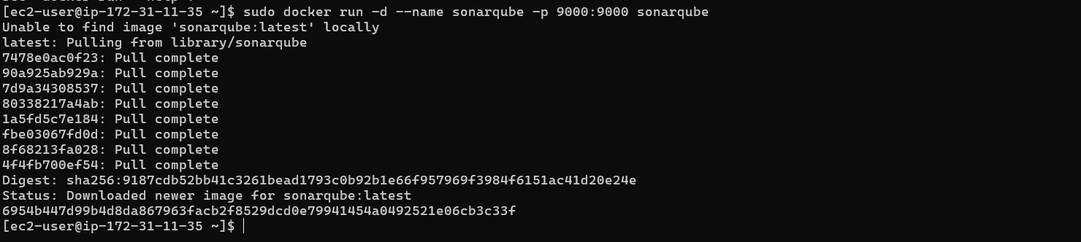

Nowyouareabletoaccessesthesonarqube. Login – admin,password –admin by default.

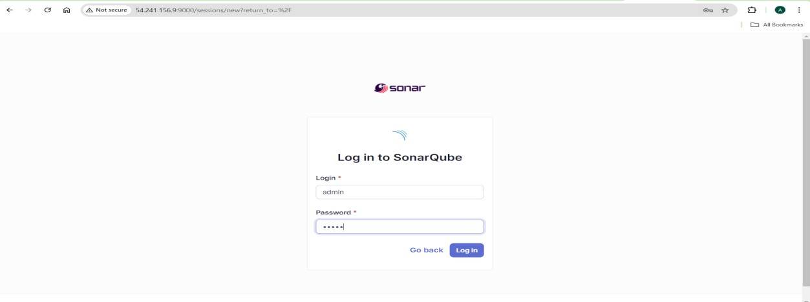

Updatenew password

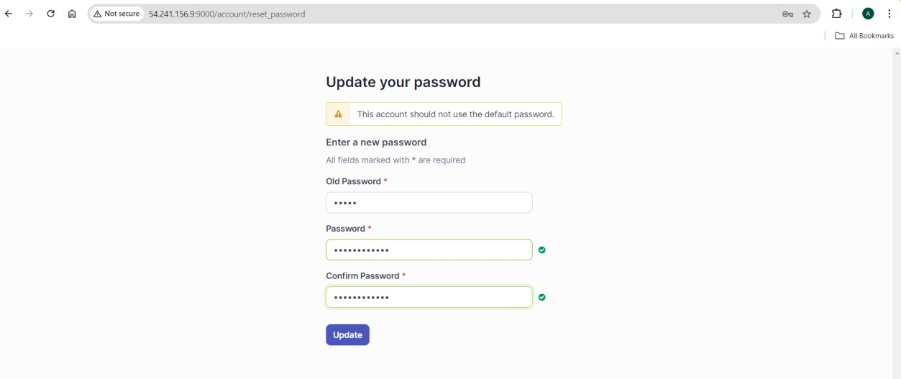

AfteryouwillseethebelowSonarqubeDashboard.

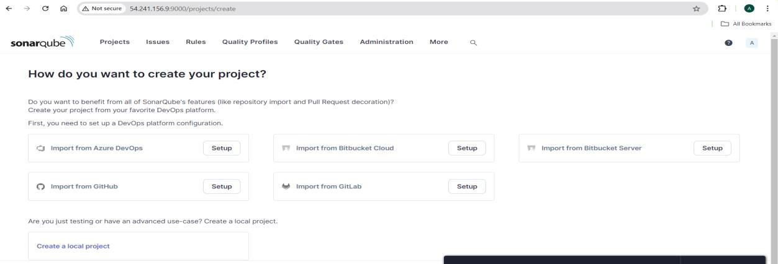

Nowwesonarqubeintegrate withJenkinswehavefollowthebelowsteps. To generate token follow the below steps:

* SonarqubedashboardtoprightclickonMyaccount.
* Thereyouwillseethesecurityoptionclickonthat.
* Givetokenname whatyouwant
* Type global.

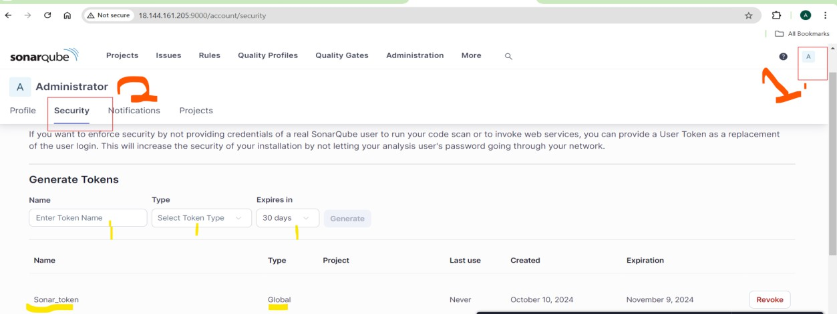

* TokenisgeneratednowgototheJenkins dashboard.
* Nowyouneedtoinstalltheplugin---soanrqube scanner

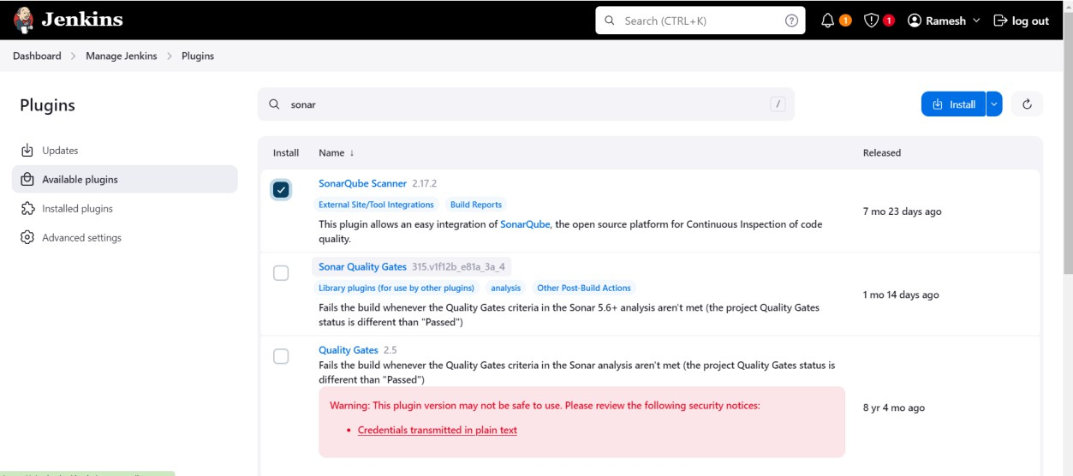

* Installwithoutrestart.
* NextGotothemangeJenkinsandclickoncredentials.

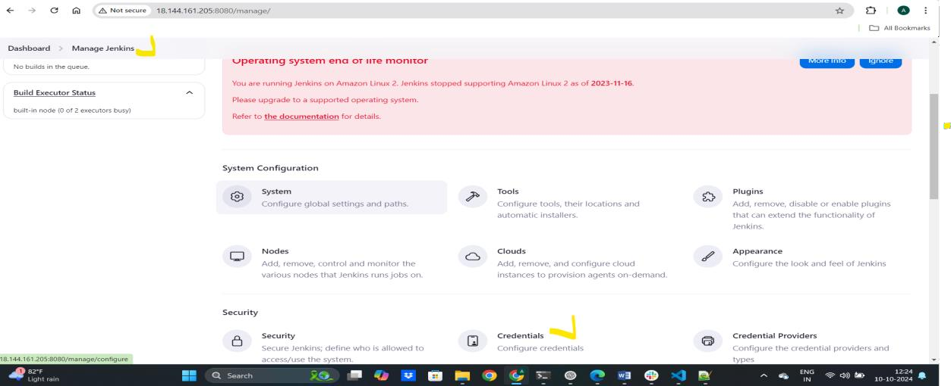

* Clickonglobalandaddcredentials.

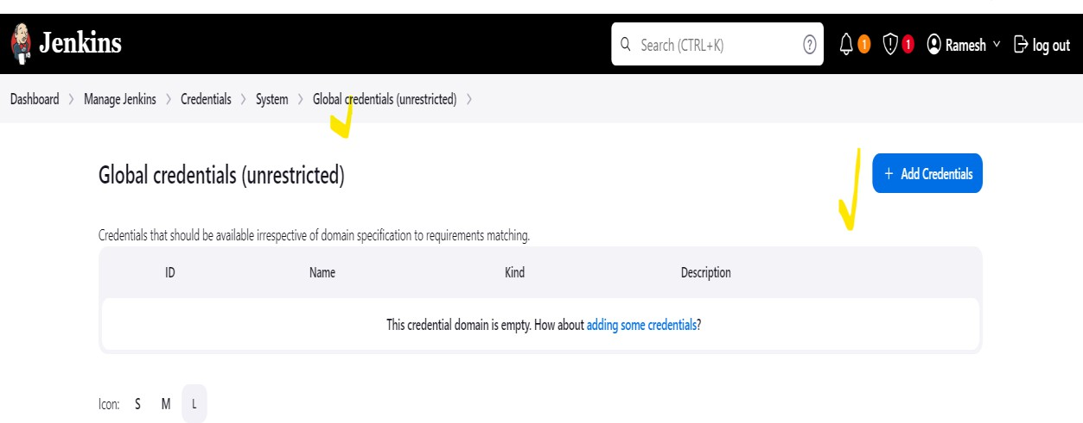

* givethecredentialsandclickoncreate.

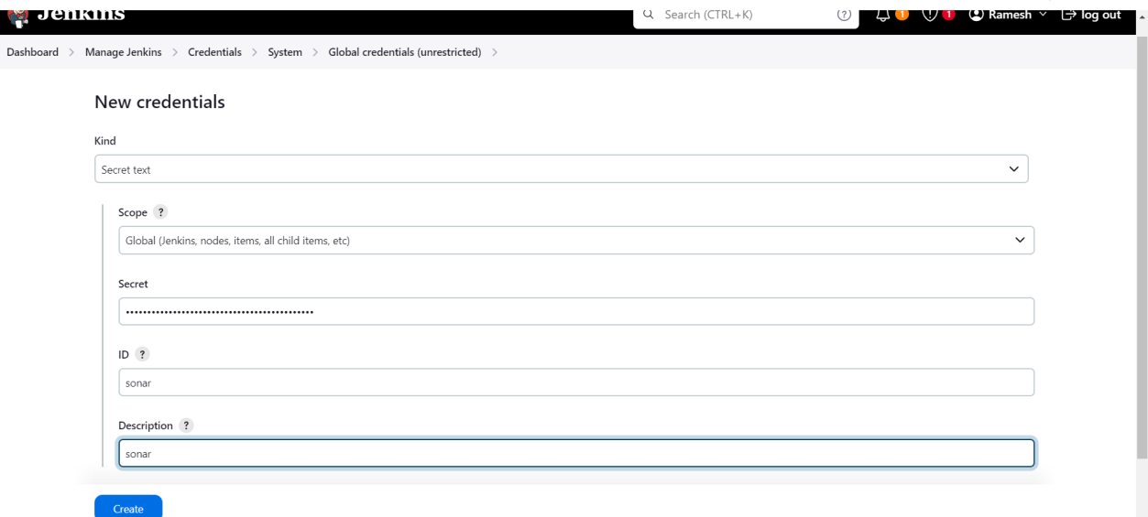

* NowGotothemanageJenkinsandsystemconfigurationthereyouneedtopasstheName, URL and select the token After click on save.

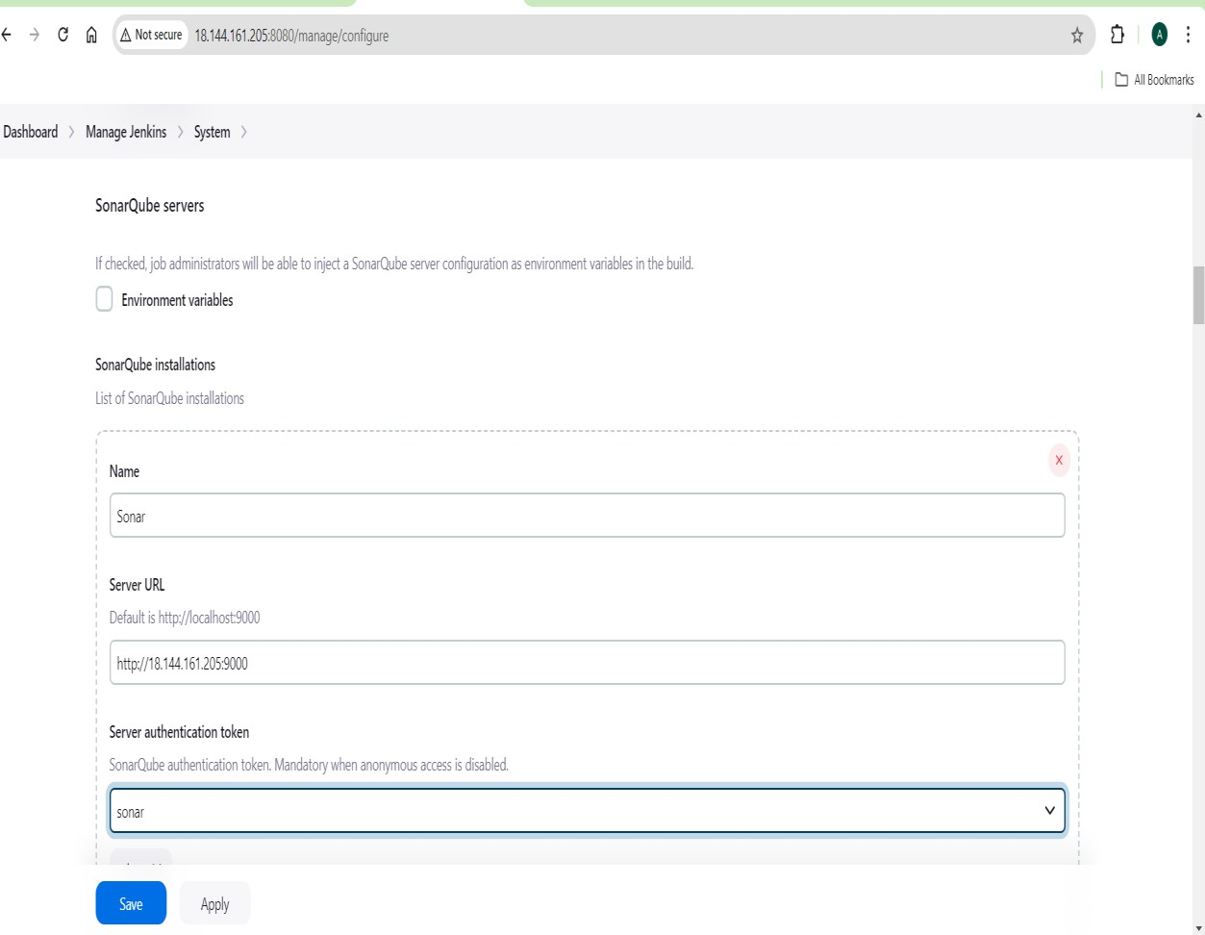

Nowsonarqubeintegrationisdone.

# AfterGototheJenkinsDashboard.

* ManageJenkins>Tools
* SonarqubeScannerinstallations givenameandselectinstallautomatically.
* Herewecaninstallmanuallywefacingtheissue.Likeversionissue’s.

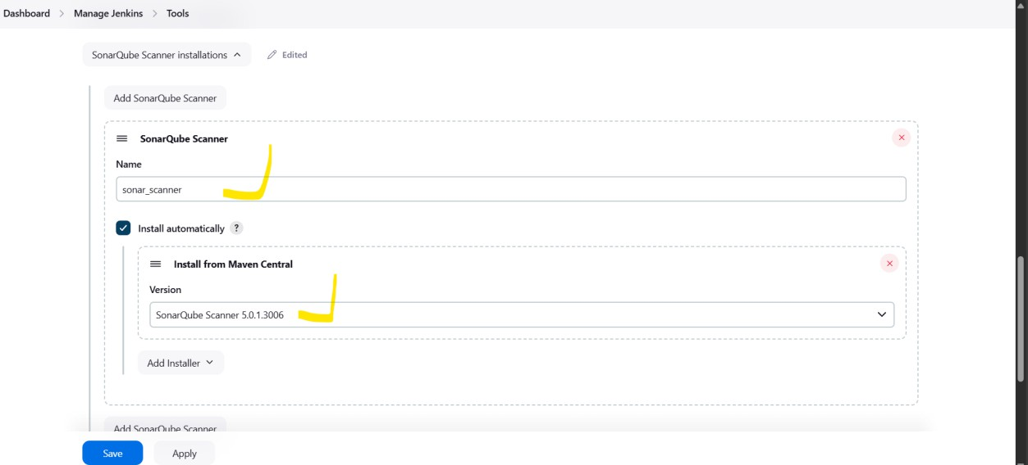

* Just clickonsave.
* TheSonarqubeandsonar_scannerConfigurationsaredone.

# MavenCompilation

* Nowgotothemaven step.
* Tobuildthecodeyouneedtoinstallmaven.
* CMD:sudoyum–yinstallmaven

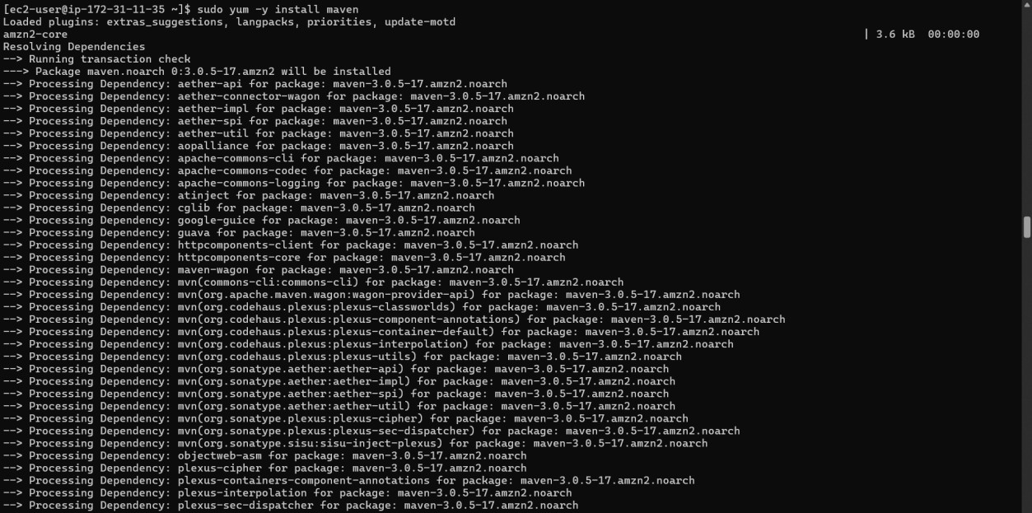

Afterthatchecktheallversionslikemavenandjava.

Settingenvironmentvariablesinyour.bash_profileallowsyoutoconfigureapplication settings and customize behavior globally. Modifying the PATH makes it easier to run commands without specifying their full paths, enhancing productivity.

* Iwent tothe.bash_profileeditedthe file.

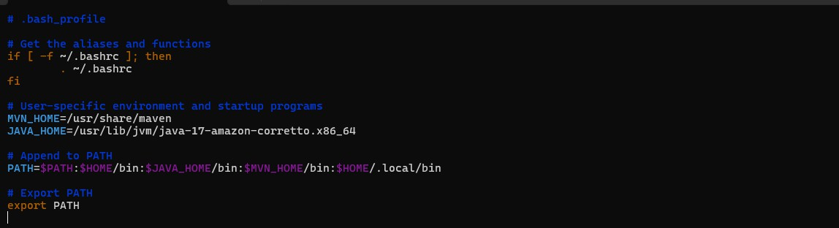

* Savethesefile.
* Nowgo toJenkins GUI.
* Goto manageJenkins, Tools.
* Givenameandpath. Afterclickon save.

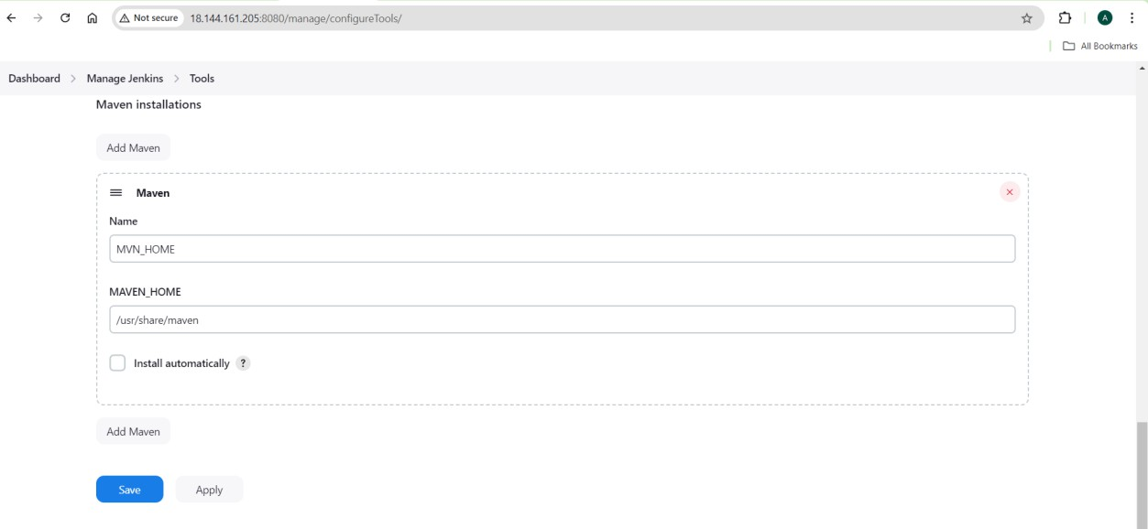

* ThemavenconfigurationsalsoDone.

# Nexus Artifactory

* Usingthe DockerIam installingNexues.

CMD:dockerrun-d--namenexus -p8081:8081 sonatype/nexus3

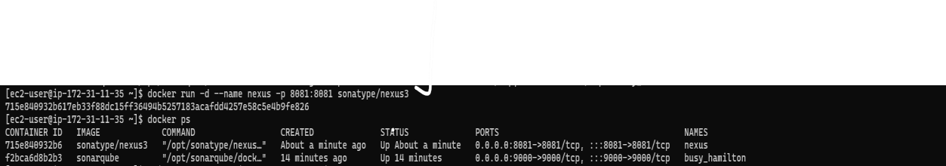

* NowtrytoaccesstheNexuswith<Ip:8081>---youseethebelowinterface.
* DefaultuserisAdmin.

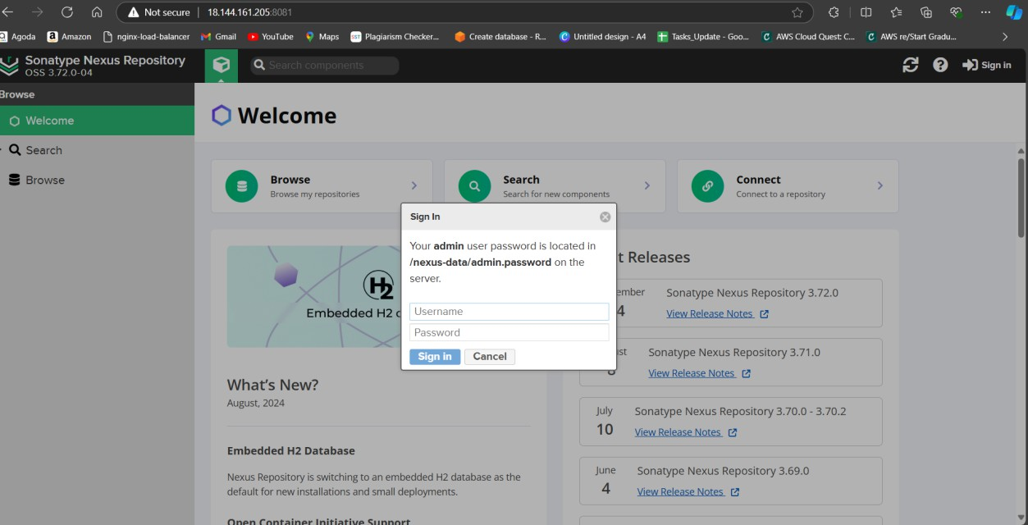

* IfyouwantpasswordgotoserverrunbelowCommand.
* CMD:dockerexec<containerId>cat/nexus-data/admin.password



* Afterthatyouneedtosetupyouruserandpassword.

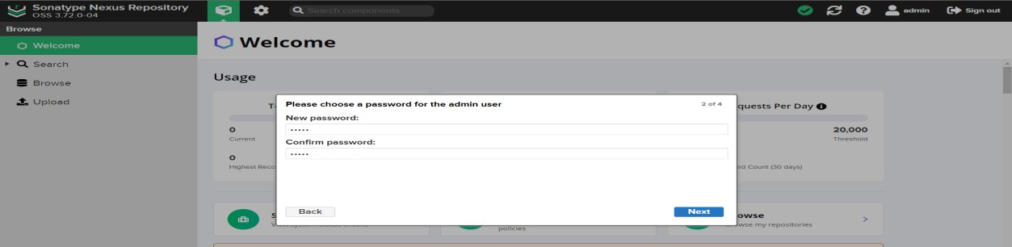

Just clickonNext.

* disableanonymousaccessandclickonnexus.
* 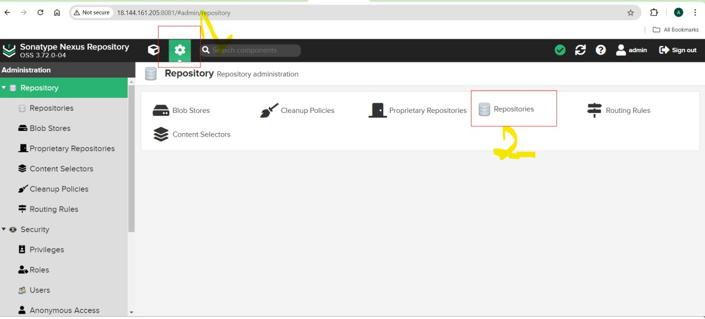NowyouneedtocreaterepoinnexusAndrepositories. Click on settings

Clickoncreate repository.

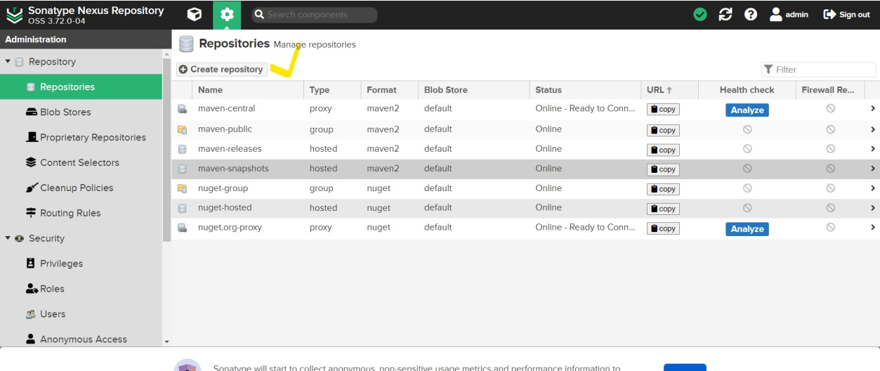

Afterclickonmaven(hosted).

Here youneedtofillrepoName,versionpolicy–release,layoutpolicy—permissive.

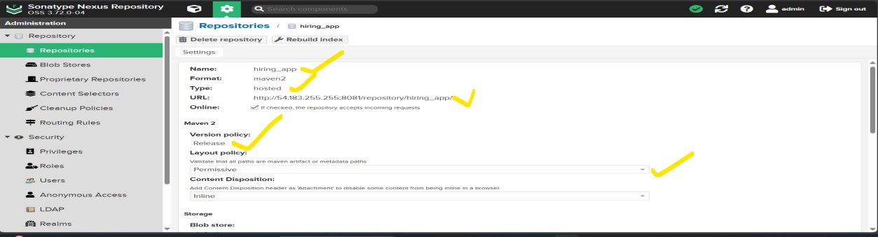

AfterthatgotoDeployment policy–redeployandclick oncreate repository.

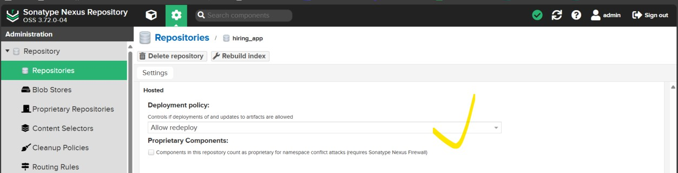

NowyourrepoisAvailable.

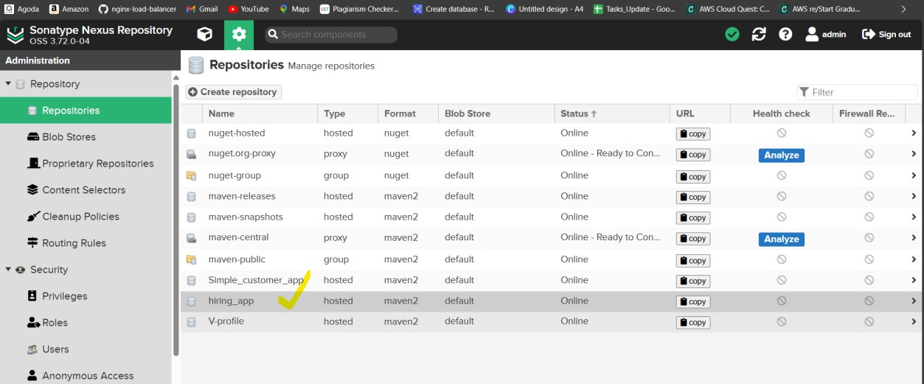

NowgototheJenkinsDashboardsandmanageJenkins.

* GOtoAvailableJenkins,searchforNexuesArtifactUploader.
* Selectcheckboxandclickon install.

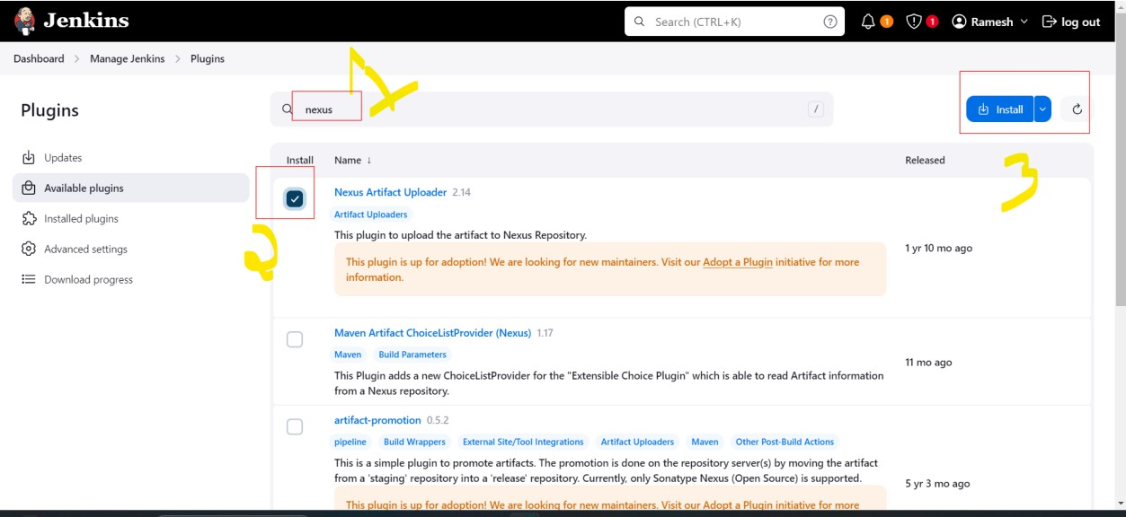

TheNexusConfigurationIsDone.

TheLastStageistomcatconfiguration.

Todownloadthetomcatclickonthelink---[ApacheTomcat® -ApacheTomcat9SoftwareDownloads](https://tomcat.apache.org/download-90.cgi)

Thereyouwillseetar.gz(pgp,sha512)---copythelink

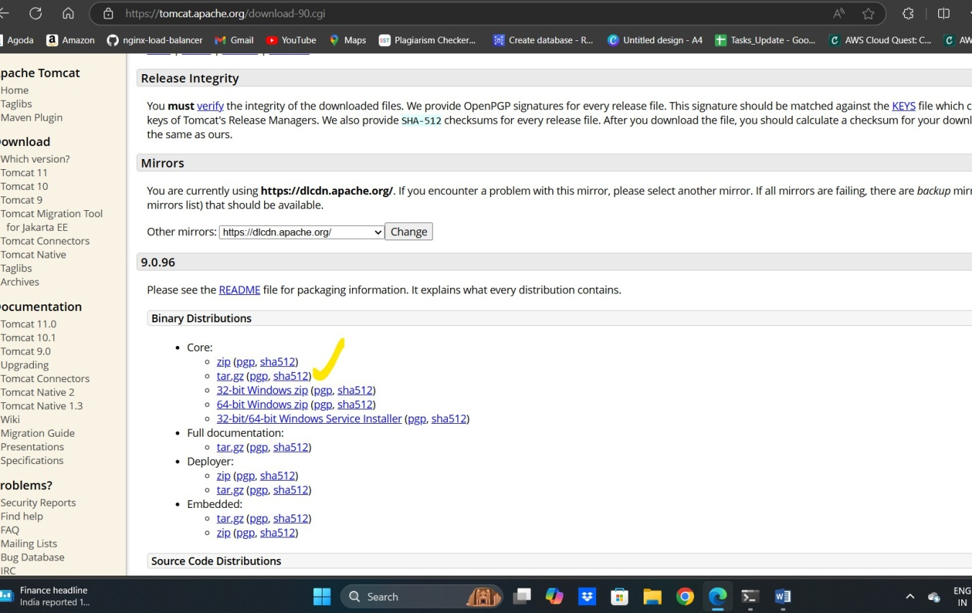

Nowgototheserverthereyouneedtoinstalltomacat. CMD: wget<link> to download form the internet

CMD:tar–xvf<link> --toextractthetar.file

Nowyouhavetostartthetomcatserver.CMD--./startup.sh

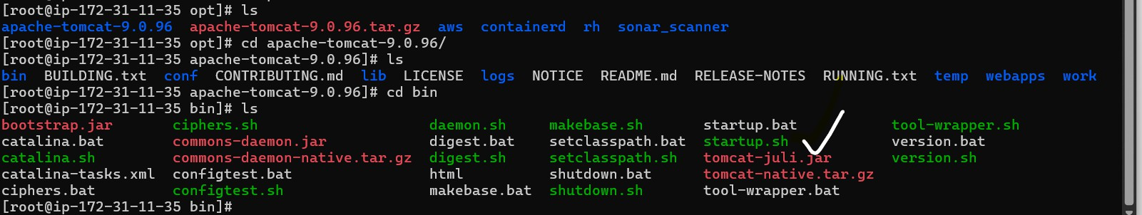

NowGotothebrowserPasteIPaddresswithPortNumber. Then you see the apache tomcat GUI.

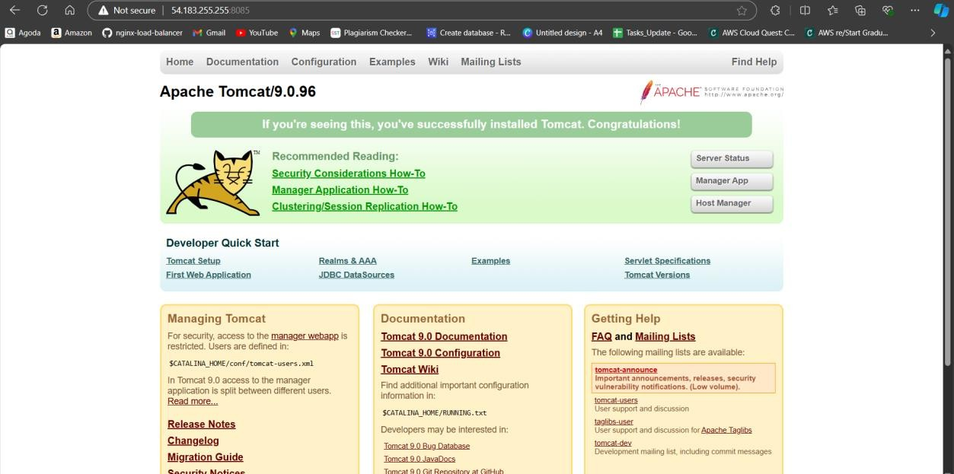

Hereyouneedtodidtheconfigurationsandaddtheuserintomacatuser.xmlfile. To find the file’suse the command – find-name context.xml

Hereleavefirstoneonlyremainingthefourfile’syouneedto edit.

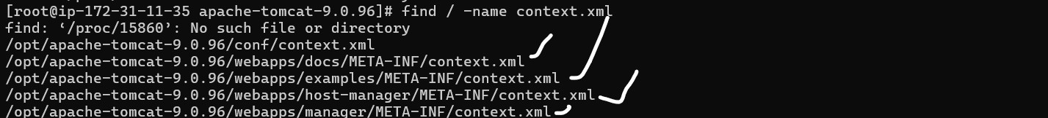

Usevieditortoopenfile

CMD:----vi/opt/apache-tomcat-9.0.96/webapps/docs/META-INF/context.xml You wil see below interface.

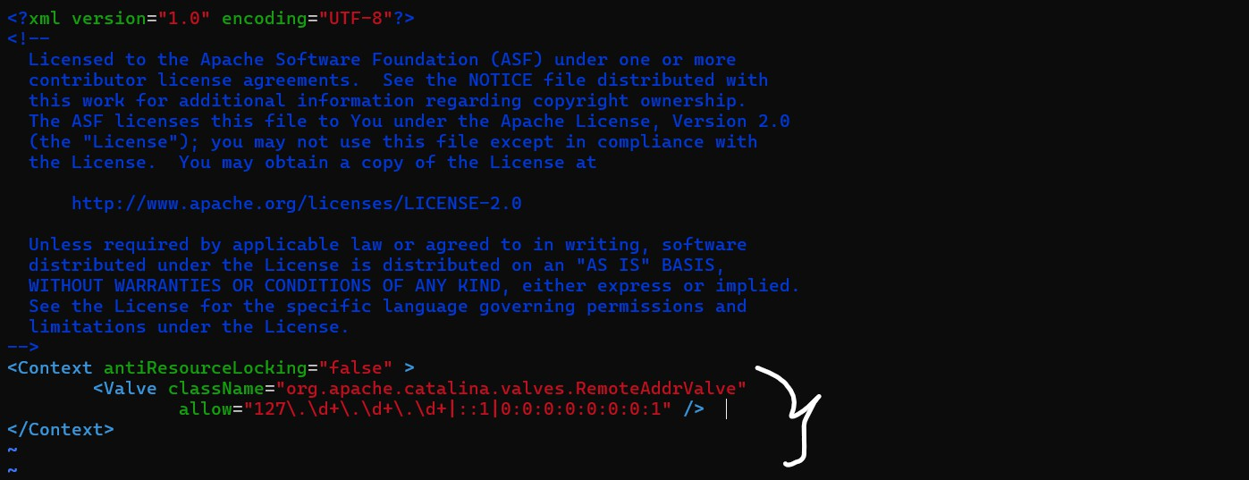

UnderthecontextyouseetheValve.

here just add like this **<!--** <ValveclassName="org.apache.catalina.valves.RemoteAddrValve" allow="127\.\d+\.\d+\.\d+|::1|0:0:0:0:0:0:0:1" />**-->**

likethischangetheall file’s.

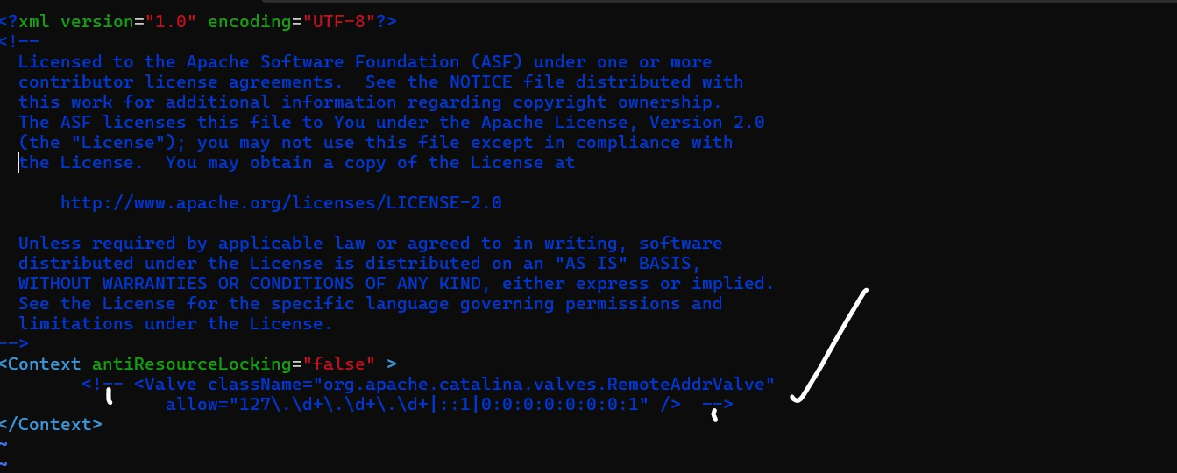

Afterchangingtheallfile’swehavetoattach user’s.

Theselocationyouseetomcat-users.xmlfilethereyouneedtoattachuser’s.

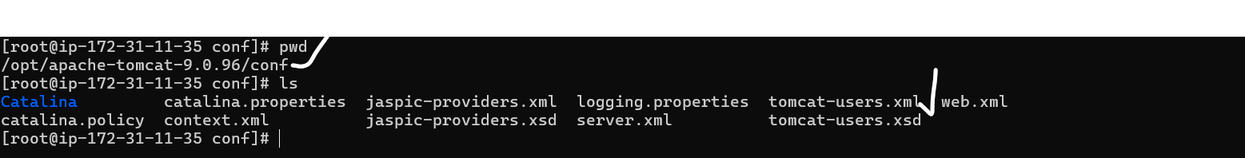

Openfilethroughvieditoraddthebellowuser’sifyouwantchangetheusernameandpassword.

<rolerolename="manager-gui"/>

<rolerolename="manager-script"/>

<rolerolename="manager-jmx"/>

<rolerolename="manager-status"/>

<userusername="admin"password="password"roles="manager-gui,manager-script,manager-jmx,manager-status"/>

<userusername="Ramesh"password="Ramesh123"roles="manager-gui,manager-script"/>

<userusername="tomcat"password="s3cret"roles="manager-gui"/>

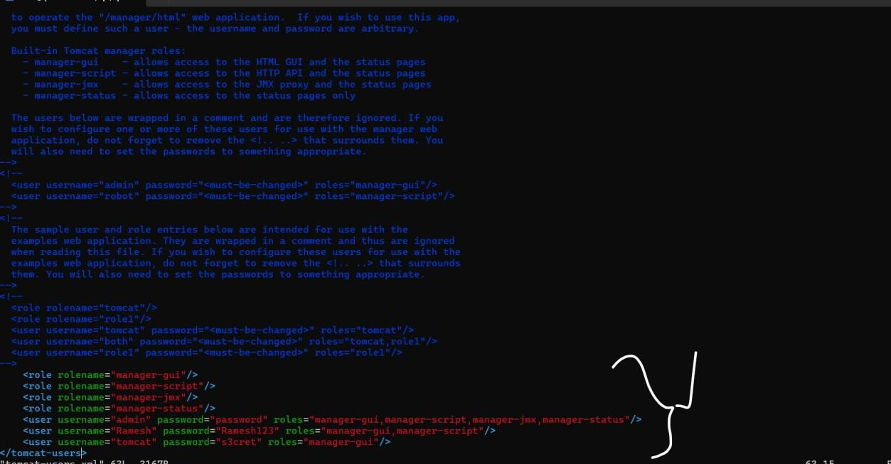

Savethe file.

Nowtrytoaccessthemanagerappandgivetheusernameand password.

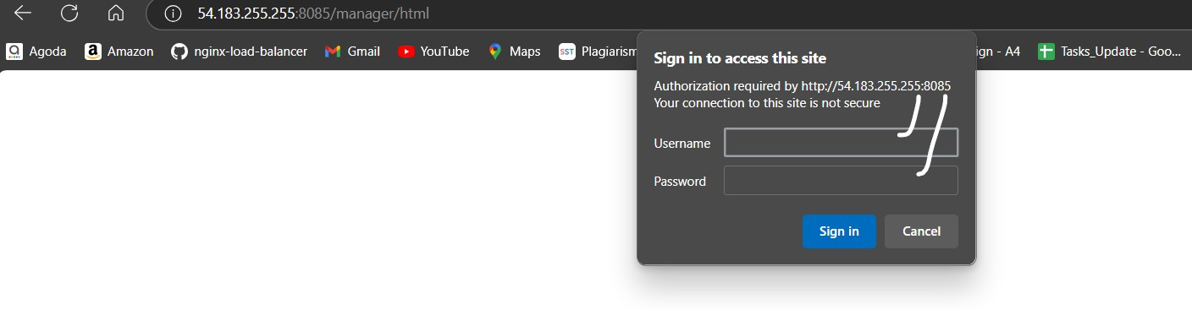

Nowweareaccess.

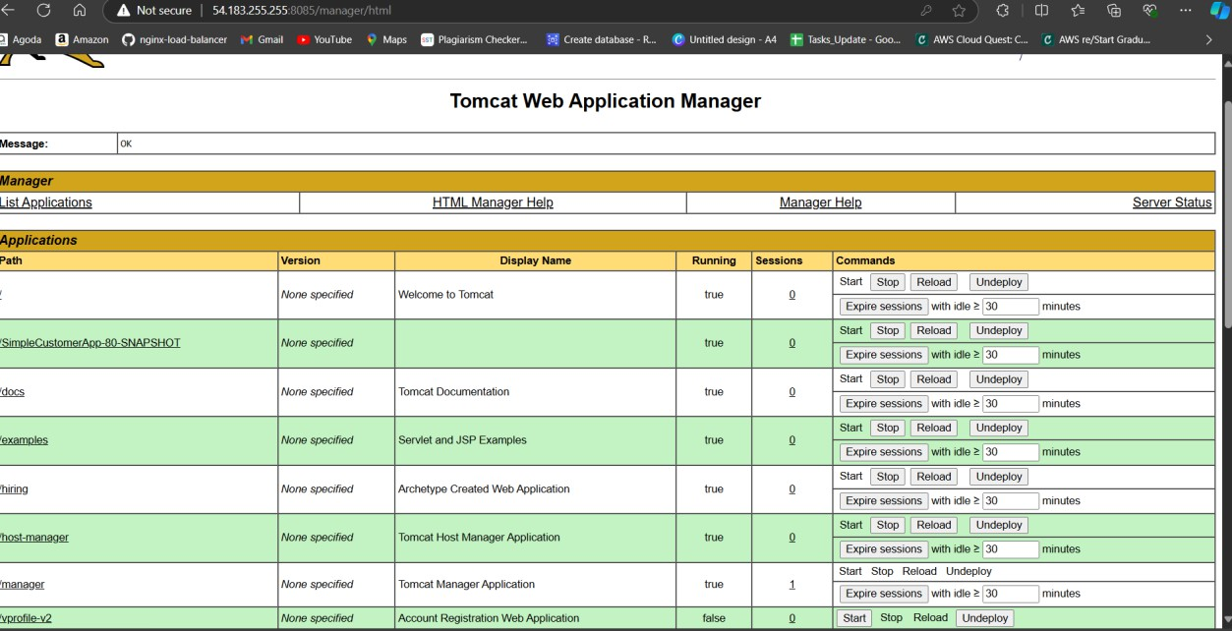

Withoutdidthisallconfigurationsandaddingtheuser’sit’snotpossibletologin.

Now the all configurations all done. Goodtogocreatejobandbuildthejob.

## GotomanageJenkins.

Gosystemglobal configurations.

NowwedidallconfigurationsowehavecreateJob.

Tocreatejobclickonnewitem,givename,andselectthefreestyleprojectandclickonok.

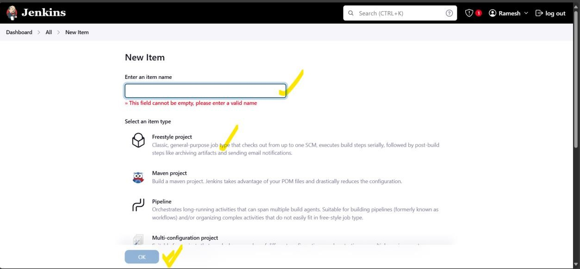

Nowgotothesourcecodemanagement.

RepositoryURL---<https://github.com/Avularamesh/hiring-app.git>

Givebranchas-- main

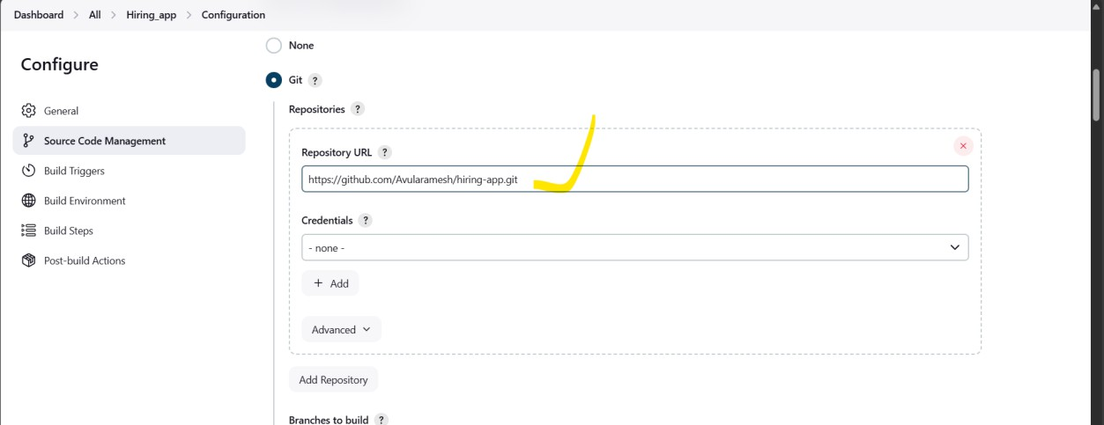

NowgotothebuildstepandclickonAddbuildstep. There you see – Execute SonarQube Scanner.

IntheAnalysisproperties thereyouneedtogivethewhatdevelopergivenanalysiscode.

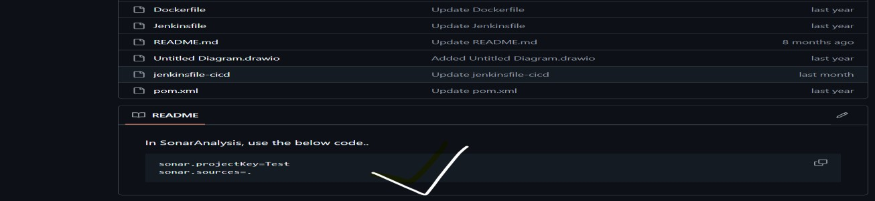

JDK inheritfromjob

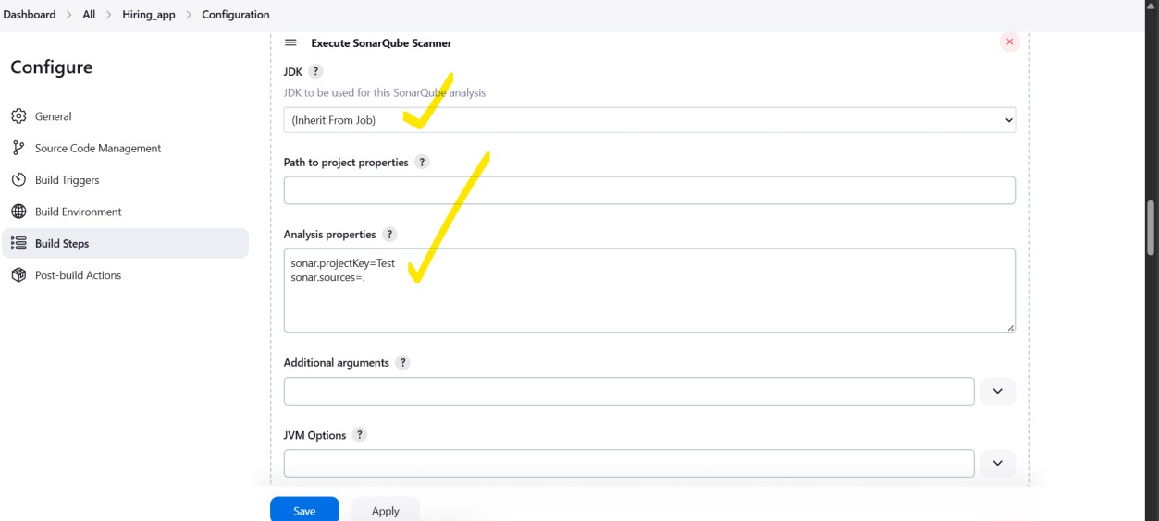

Nextstageis– Build

* AgainbuildstepandclickonAddbuildstep.
* ThereyouseentheInvoketop-levelmaventargets.
* Mavenversion–selectMVN_HOME
* Goal–cleaninstall

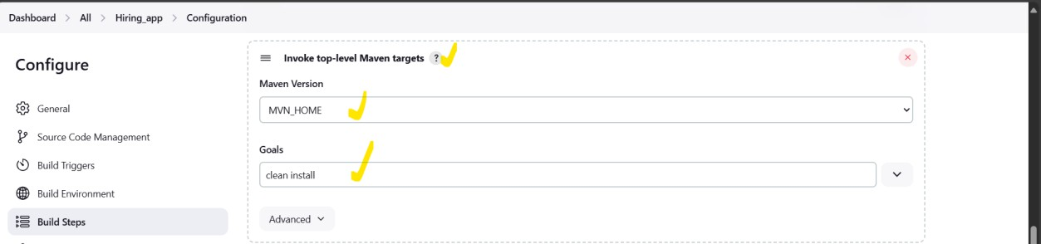

NowNextstagenexus

* AgainbuildstepandclickonAddbuildstep.
* SelectNexusartefactuploaderandversion NEXUS3
* Protocol---HTTPandgiveNexusURL <URL>
* Selectthecredentialswhatyousavedintheglobalcredentials.

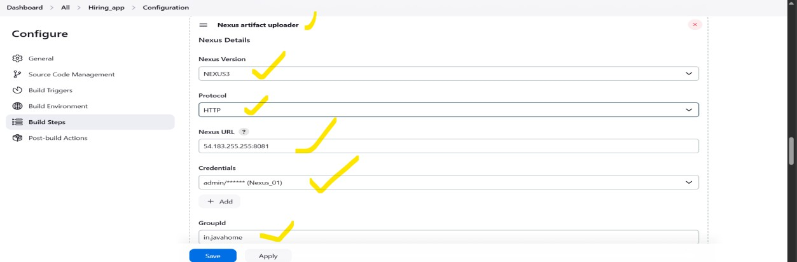

theaboveIamgivengroupIDwehavetookinPom.xmlfile

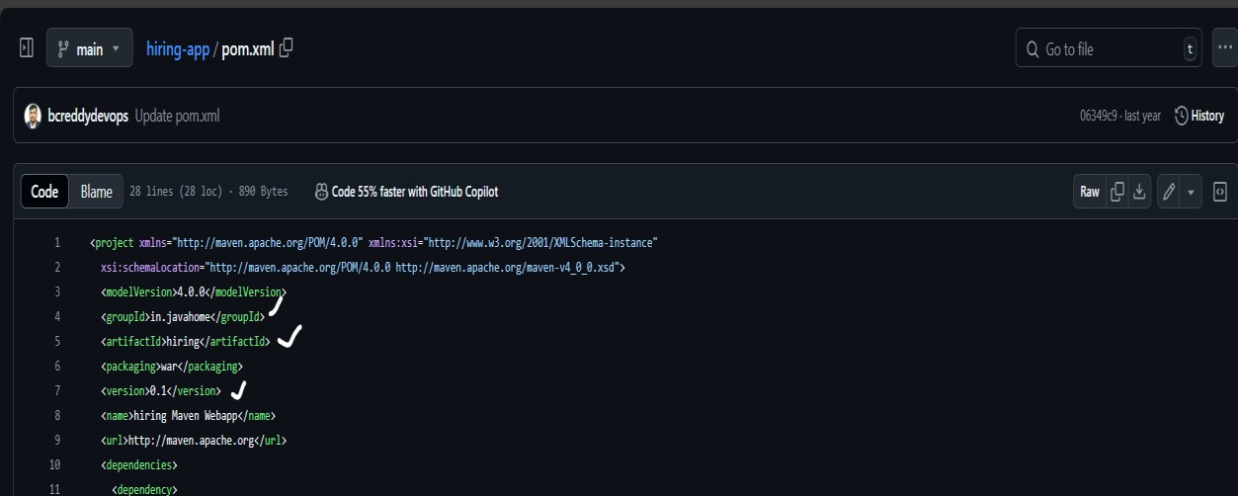

* Hereversion---0.1
* Repositoryname givenexuswhatwecreatedreponame.
* ArtifactId---hiringand type war

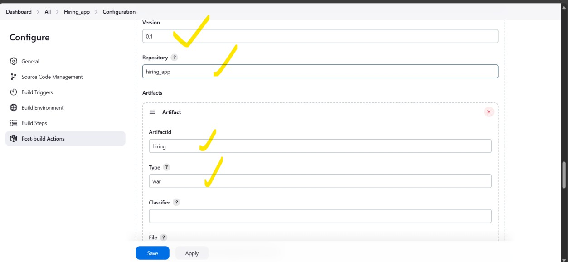

File–giveyourfilelocationthatwillbegeneratedafterbuild.

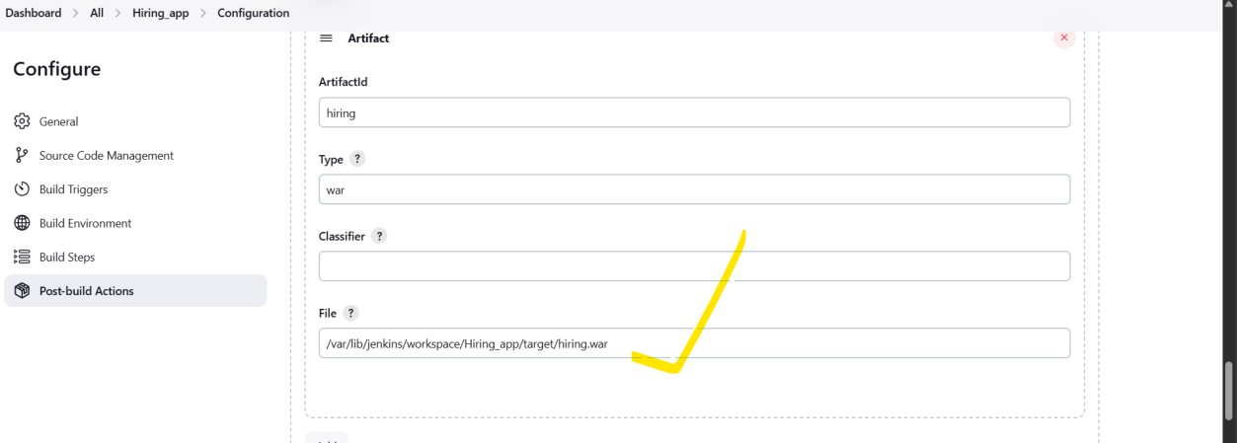

* AfterNexuswehavetodeploywarfileinatomcat.
* Gotothepostbuildactionsclickon---Deploywar/eartocontainer.
* WAR/EARfiles **/*.waralways
* AfterthatgivethecredentialsoftomcatandgiveURLof tomcat.

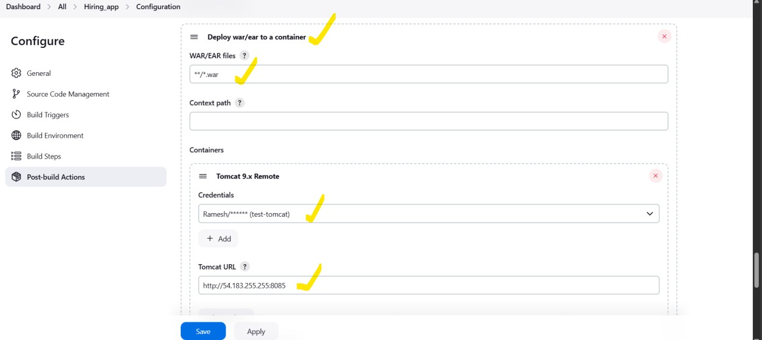

* AgaingothePostbuildactionsclickonSlackNotifications.
* Thereyouneedtoselect –Notifysuccess,NotifyAborted,notifyeveryfailure.
* Aftermadethischangesclickonapplyandsave.

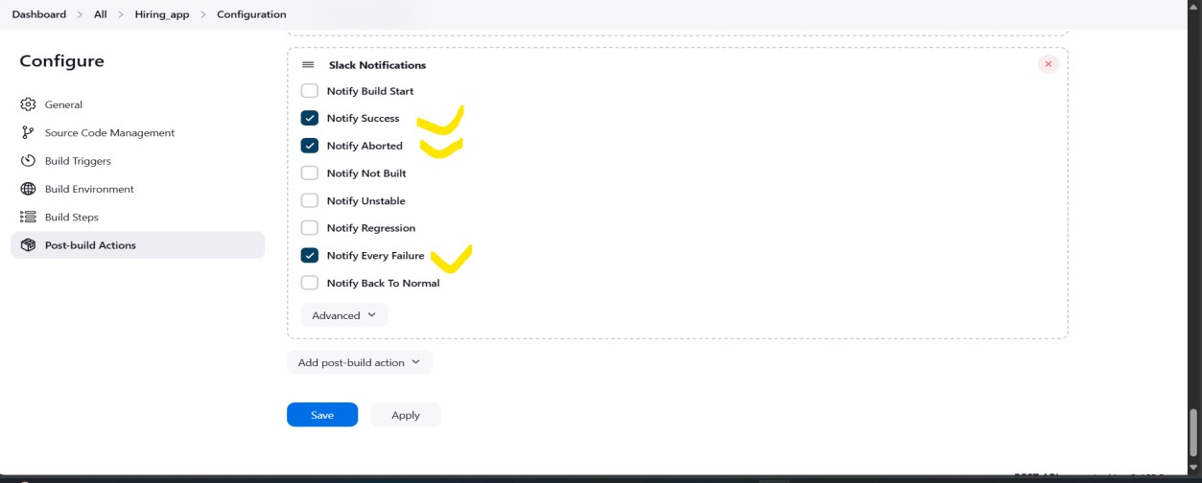

NowbuildtheJob

Thefirststageis successfule.

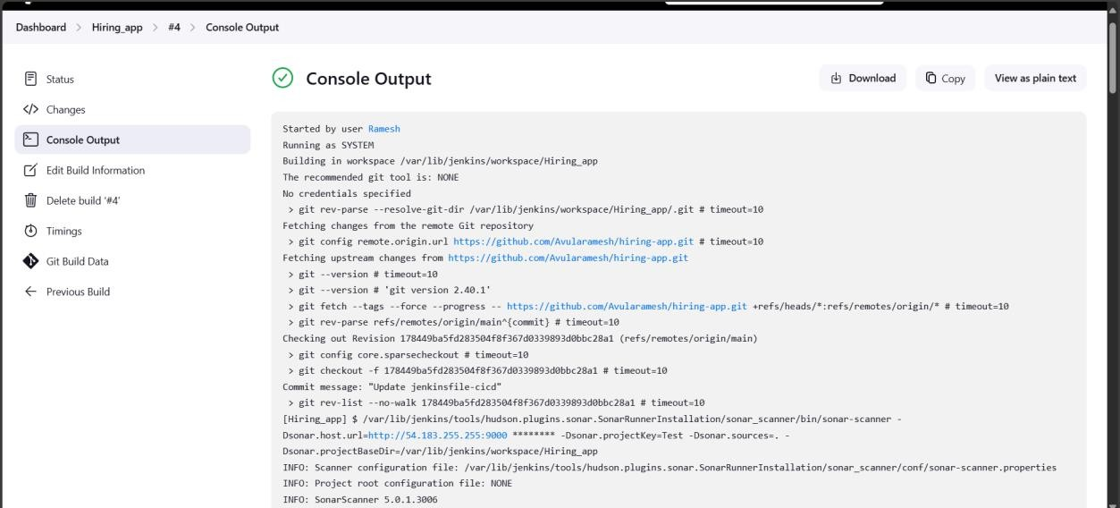

Secondstagealso successfule.

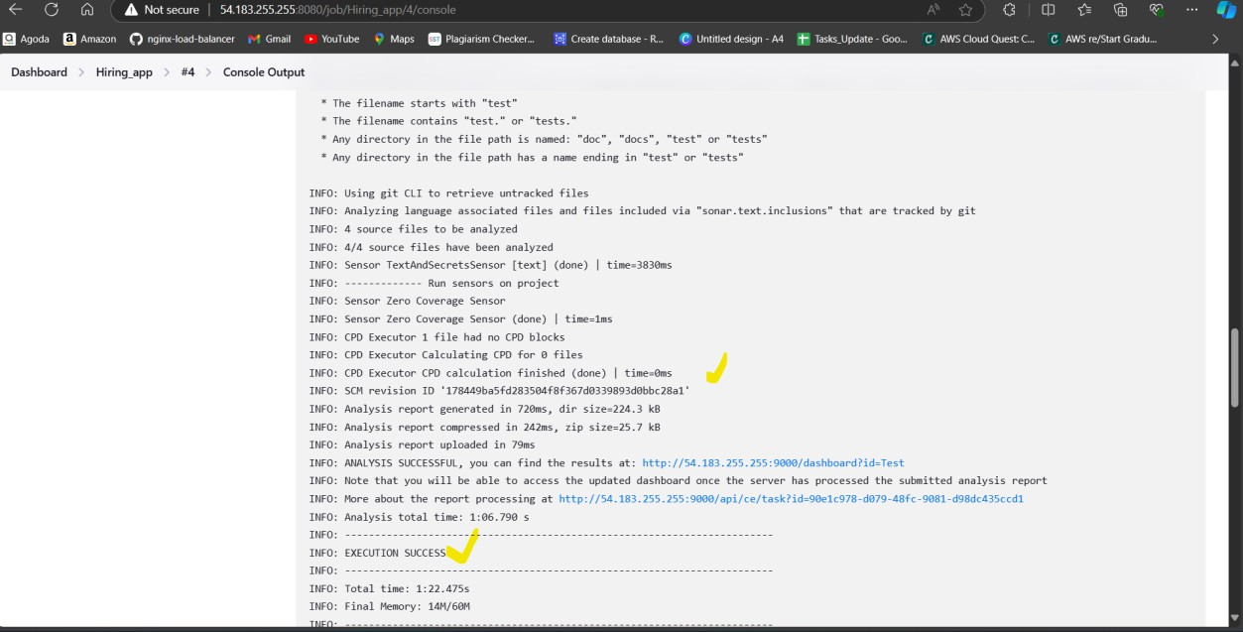

Youseeinsonarqubealsolikewhatbugsaretherethequalitygateispassedornotand Duplications.

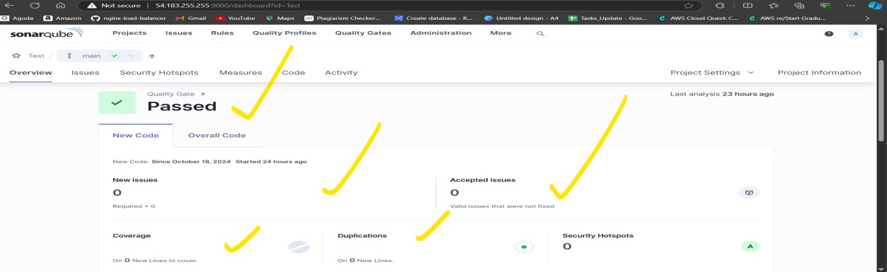

TheNextstageisbuildstage. This stage also succesfule.

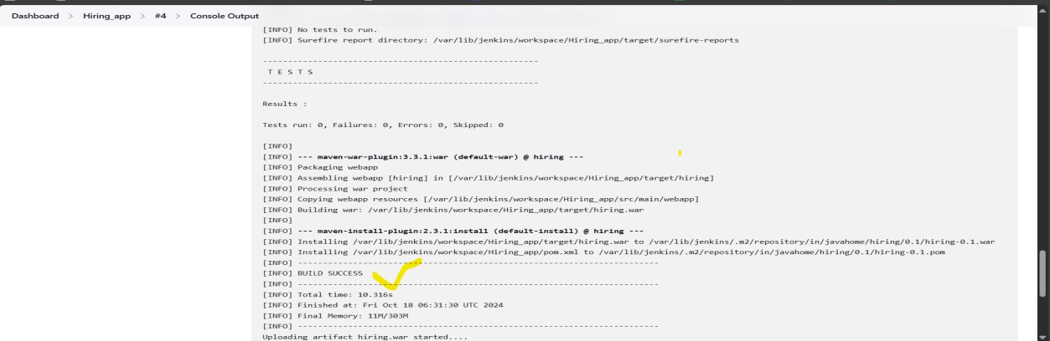

Thislocationwariscreated.

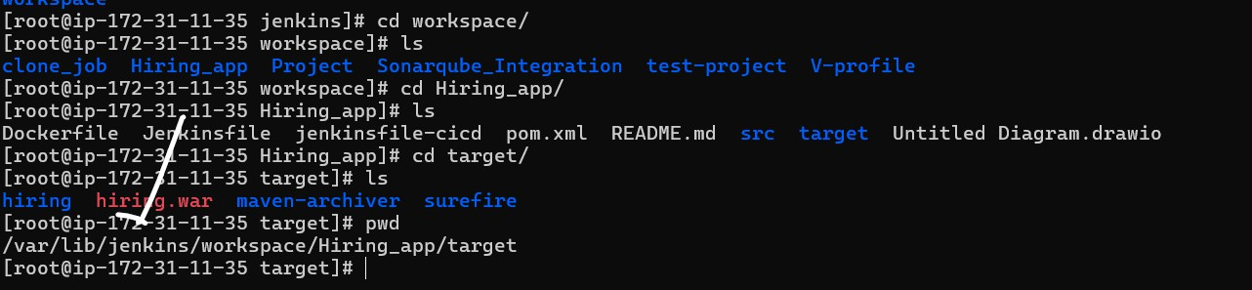

Uploadthewarfileintonexus.

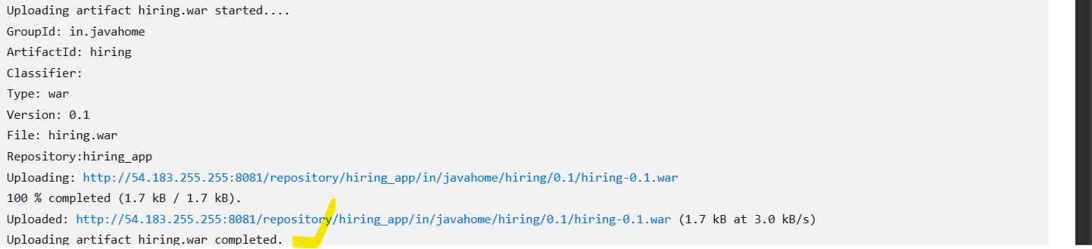

Warfileaslouploadedintonexues.

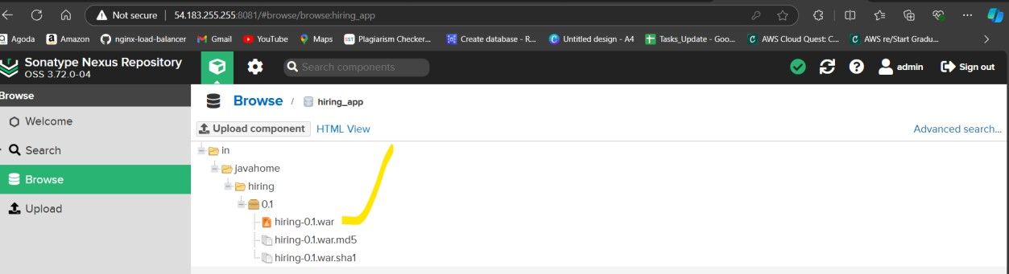

NowDeploytotomcatserver.

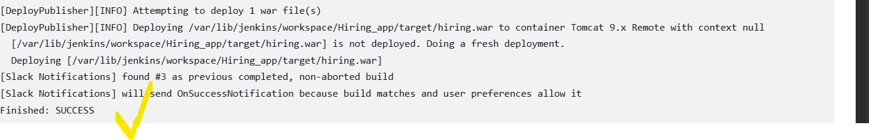

Justclickon/hiring

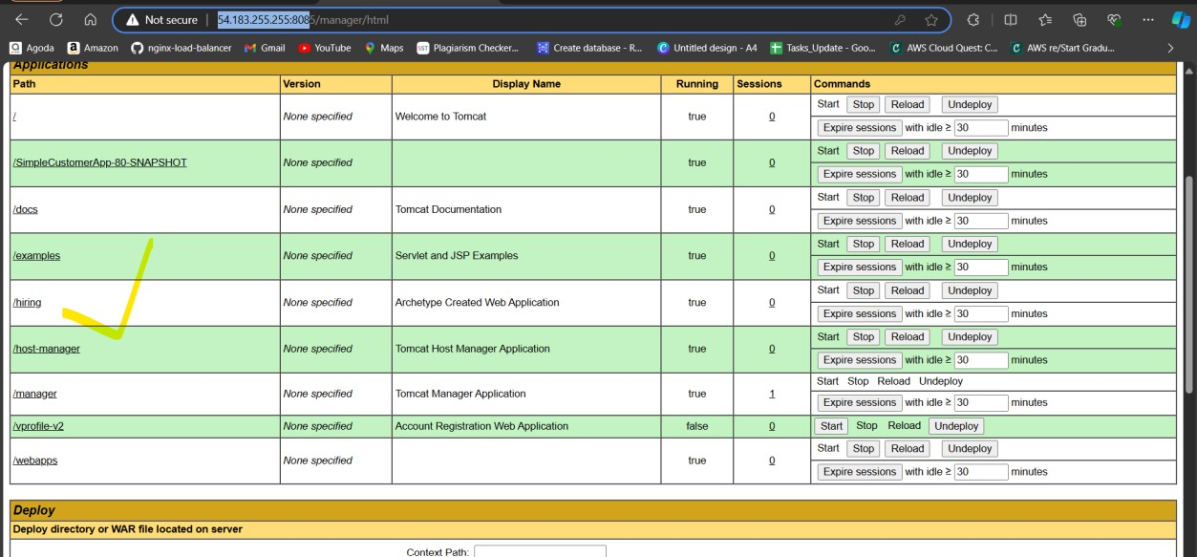

Youseelikethe these.

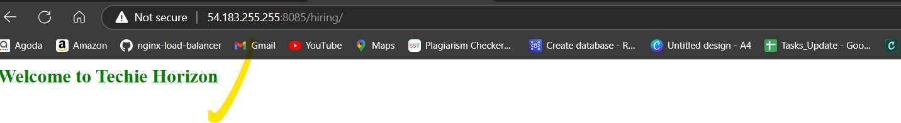

slacknotificationalsoDone.



Taskiscompleted.

Issue:inthebadcaseIforgottheJenkinsadminpasswordthattime Iamunabletologinthatpoint off time I followed below the steps.

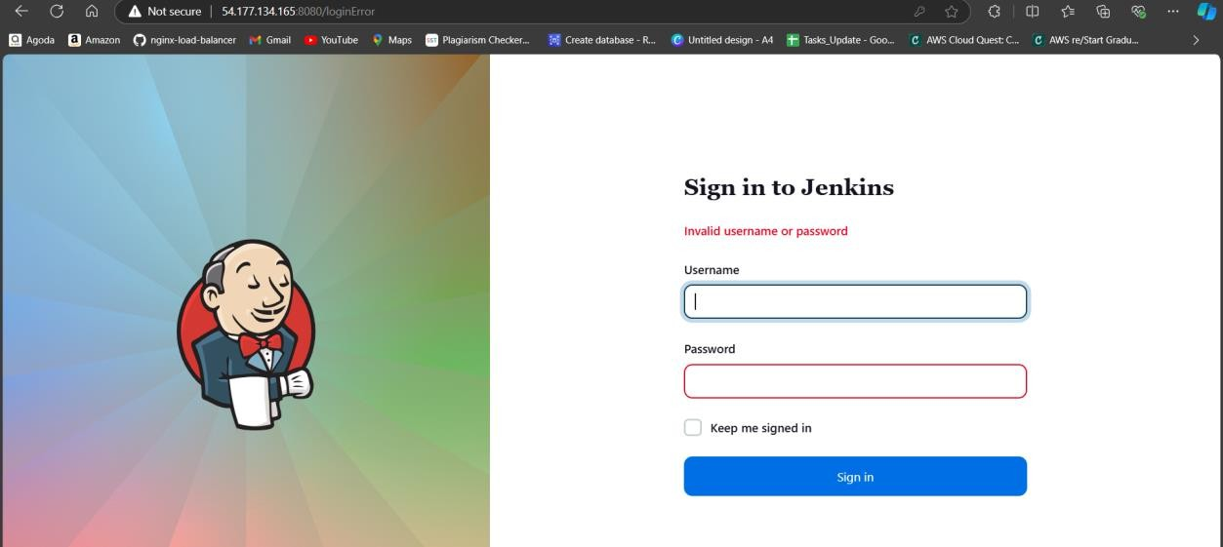

ThenIconnecttotheec2server. I edit the file.

CMD:vi /var/lib/jenkins/config.xml

<usesecurity>true</usesecurity>

Ichangeitasthefalse.<usesecurity>false</usesecurity>

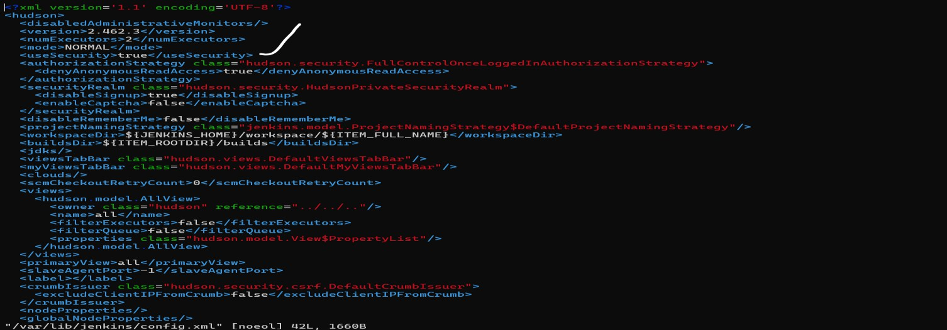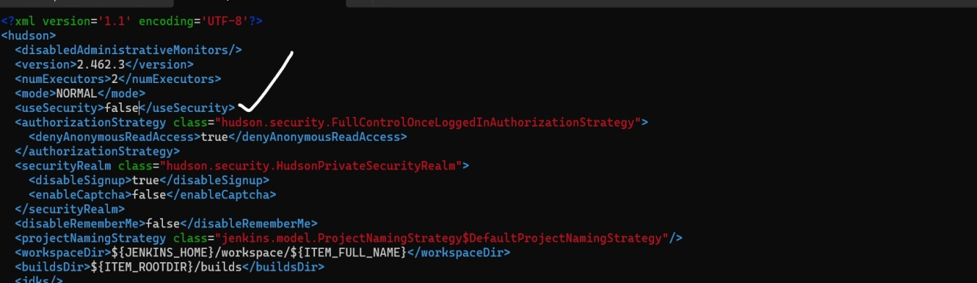

Afterchangingasfalsesavethefile.

YouneedtorestarttheJenkinsserver.CMD:systemctlrestartjenkins Then now try to login. Now you can access the Jenkins GUI.

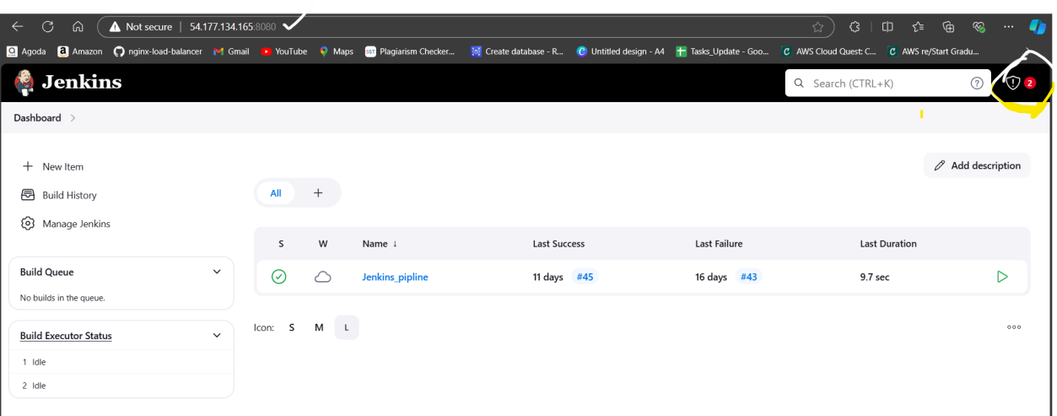

* UserhavethecredentialthatwillsecuretheJenkinsserverandthisisbeestpracticeto secure the Jenkins server.
* ButyournotLoginasadminuser.Sothisthisisnotbestpractice.Soyouneedtochangethe password of admin user.

Tochangethepasswordyouneedtofollowthebelowsteps:

* GotothemanageJenkins.
* Herewehaven’tfoundandoptionasusers.Sogotothesecurity credentials.

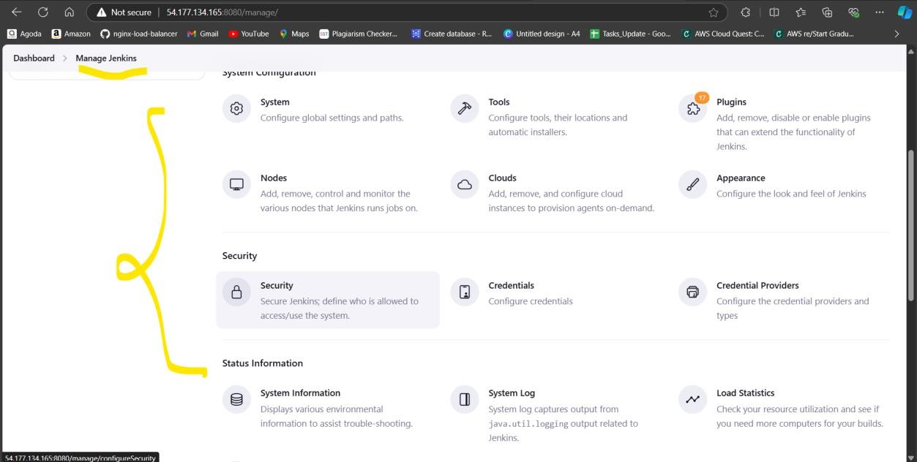

* Thenyouwillthebelowinterface.
* YouseetheoptionSecurityRealm---None

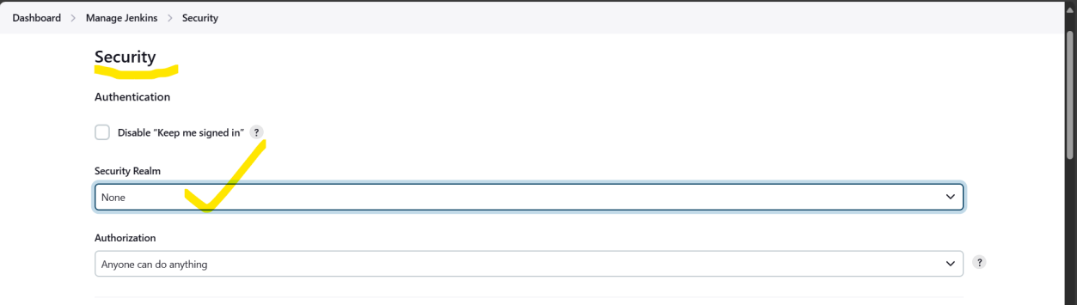

* + ChangeasJenkin’sownuserdatabase.
  + ThensaveandcomebacktomanageJenkins.

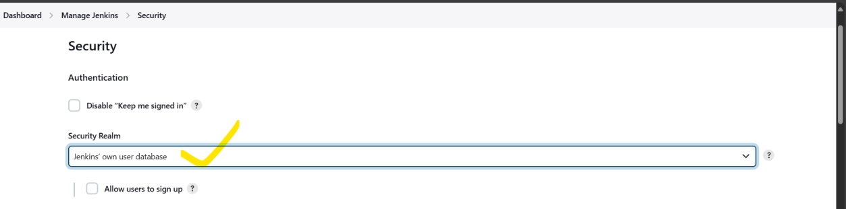

Nowyoucanseetheuser’sOptionandclickonthat.

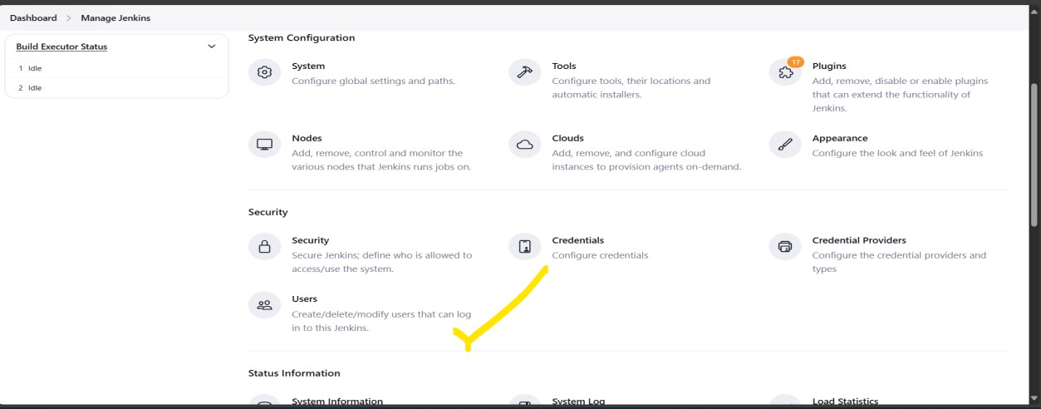

Clickon admin.

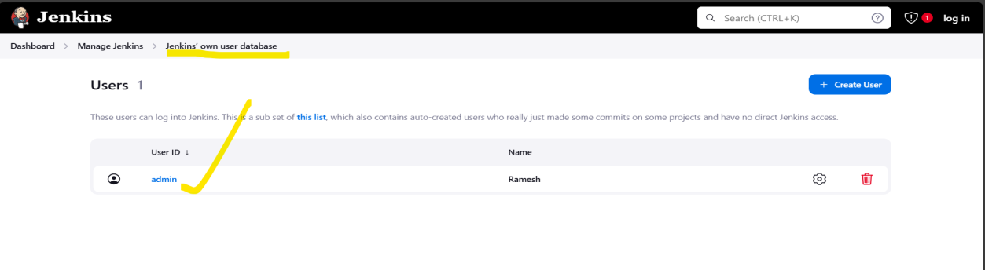

Afterthatclickonconfigureandscroll down.

Youseethepasswordandyouneedtochangethepassword.

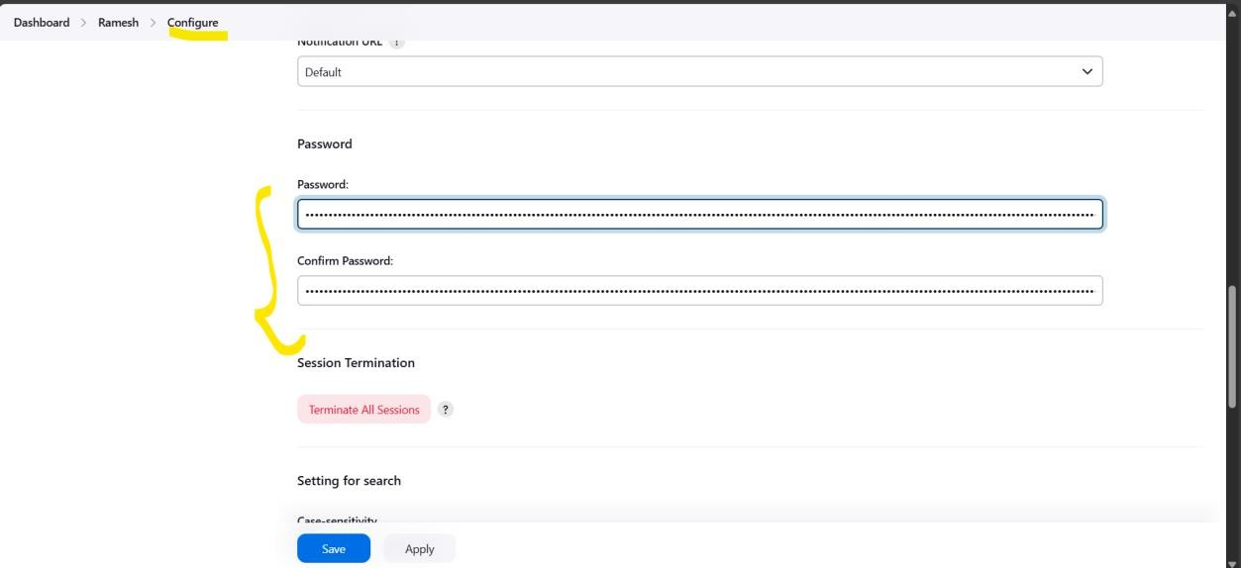

HereIam givenmynewpasswordandclickonthesavebutton.

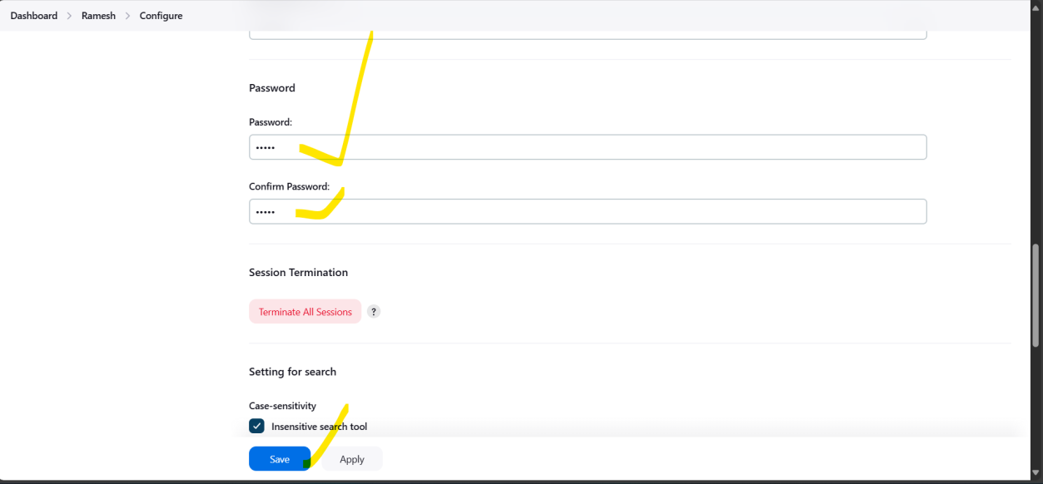

Afterthatgotothebrowser---<Ipaddres:8080/login> Now give your user name and password.

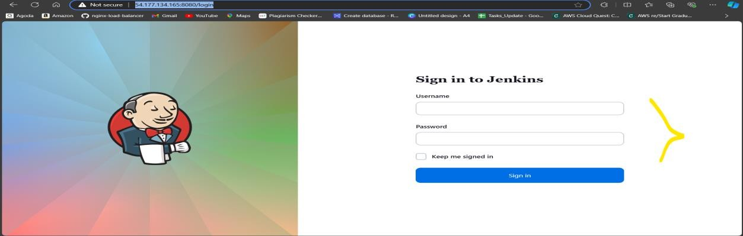

Nowyoucanaccesses asuser.

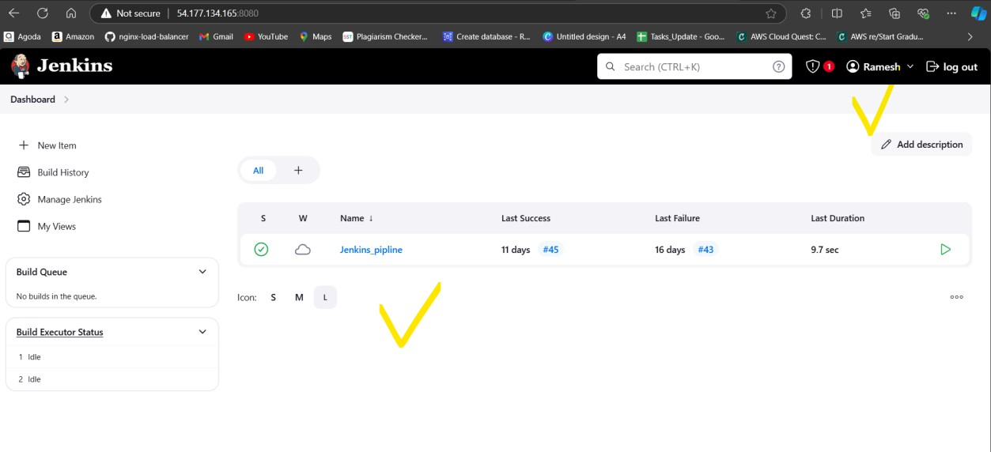

ButherewefacingtheproblemNow.

withouripaddress:<protnumber>anyoneaccesstheourJenkinsGUI.

Thisnotgoodforourorganizationsotosolvethatweneedtochangethesomeconfigurations. To secure our Jenkins GUI follow below steps:

* + Connecttotheserver.
  + vi/var/lib/jenkins/config.xmlopenthisfile

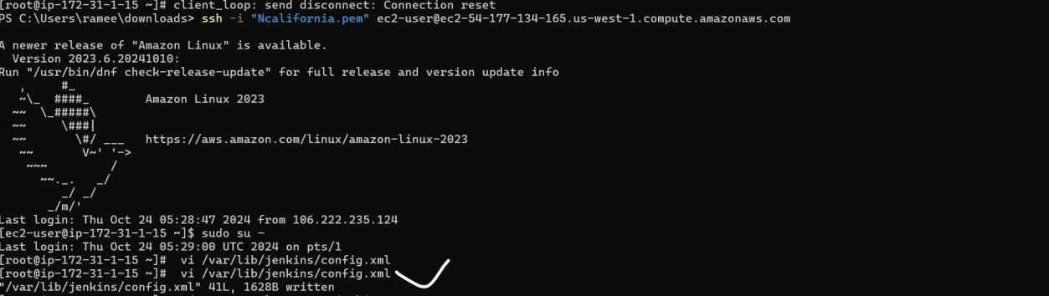

Thereyouneedtoobserve<authorizationstrattegy>hereyouneedtochange.

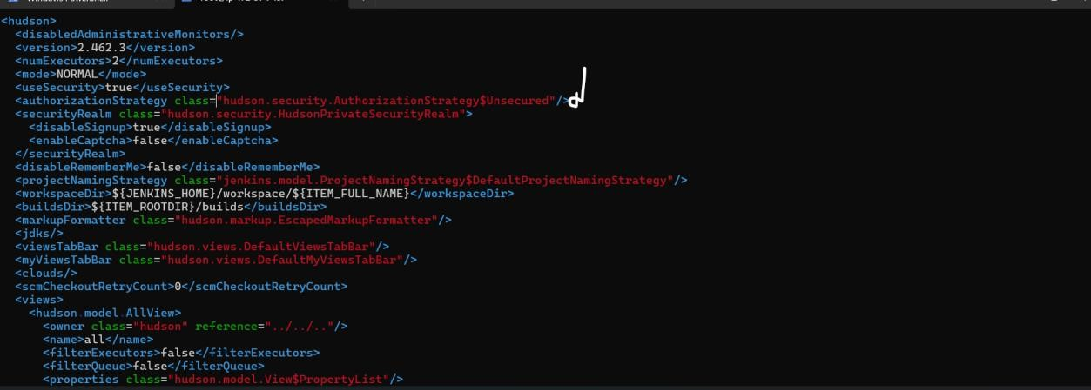

Thislinesyouneedtoaddinthefile.

<authorizationStrategyclass="hudson.security.FullControlOnceLoggedInAuthorizationStrategy">

<denyAnonymousReadAccess>true</denyAnonymousReadAccess>

</authorizationStrategy>

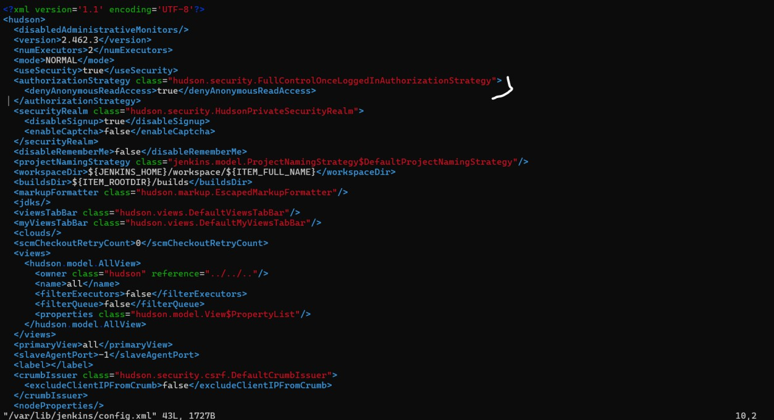

Afterthatsavethefileandrestartthe Jenkinsserver.

TorestarttheJenkinsserverCMD:systemctlrestartJenkins Then go to the browser http://54.177.134.165:8080/

ItwillautomaticallyasktheLogincredentials. Give the credentials and Login.

